Object
–
Oriented
Programming
OOPS

- Object-oriented programming (OOP) is a programming paradigm based on the concept of "objects".
- OOP concepts include object, classes, constructor and encapsulation, polymorphism, and inheritance,Abstraction.
- An object-oriented paradigm is to design the program using classes and objects. Python programming language supports different programming approaches like functional programming, modular programming.
- An object has the following two characteristics:
- Attribute
- Behavior
- For example, A Car is an object, as it has the following properties:
-name, price, color as attributes
-breaking, acceleration as behavior
- For example, you are creating a vehicle according to the Vehicle blueprint (template). The plan contains all dimensions and structure. Based on these descriptions, we can construct a car, truck, bus, or any vehicle. Here, a car, truck, bus are objects of Vehicle class

Summary of OOP Pillars in Python
Concept | Purpose
Class | Blueprint for objects
Object | Instance of a class
Encapsulation | Hide and protect data
Inheritance | Reuse code via parent-child relationship
Polymorphism | Same method, different behavior
Abstraction | Hide complexity

Example:
class myclass:
x=20
p1=myclass() # object
print(p1.x)

Output: 20
__init function or Constructor

- The examples above are classes and objects in their simplest form, and are not really useful in real life applications.

- To understand the meaning of classes we have to understand the built-in __init__() function.
- All classes have a function called __init__(), which is always executed when the class is being initiated.

- Use the __init__() function to assign values to object properties, or other operations that are necessary to do when object is being created.

- Note: The __init__() function is called automatically every time the class is being used to create a new object.

- The self parameter is a reference to the current instance of the class, and is used to access variables that belongs to the class.
- It does not have to be named self , you can call it whatever you like, but it has to be the first parameter of any function in the class

Example:

class detail:
def __init__(self,name,age):
self.name=name
self.age=age
p=detail('Avisha',26)
print(p.name)
print(p.age)

Output:
Avisha
26

- Object Methods : Objects can also contain methods. Methods in objects are functions that belong to the object.

- Modify object properties
Example:
class Person:
def __init__(self, name, age):
self.name = name
self.age = age
def myfun(self):
print(f"{self.name},{self.age}")
p=Person('Avisha',25)
p.myfun()
p.age=30
p.myfun()
Output:
Avisha,25
Avisha,30

Encapsulations

- Using encapsulation, we can hide an object’s internal representation from the outside. This is called information hiding.

- encapsulation allows us to restrict accessing variables and methods directly and prevent accidental data modification by creating private data members and methods within a class.

- Encapsulation is a way to can restrict access to methods and variables from outside of class. Whenever we are working with the class and dealing with sensitive data

- Access modifiers limit access to the variables and methods of a class.

- Python provides three types of access modifiers private, public, and protected.

- Public Member: Accessible anywhere from outside the class (Defualt)

- Protected Member: Accessible within the class and its sub-classes (using single underscore)

- Private Member: Accessible within the class (double underscores)

Example:

class Employee:
def __init__(self, name, salary):
self.name = name # public data member
self.__salary = salary # private member
emp = Employee('Hardik', 50000) # creating object of a class
print('Name:', emp.name)
# print("salary:",emp.__salary) # accessing private data members

Output:
Name: Hardik

Inheritance

- The process of inheriting the properties of the parent class into a child class is called inheritance. The existing class is called a base class or parent class and the new class is called a subclass or child class or derived class.

- In inheritance, the child class acquires all the data members, properties, and functions from the parent class. Also, a child class can also provide its specific implementation to the methods of the parent class.

- For example, In the real world, Car is a sub-class of a Vehicle class. We can create a Car by inheriting the properties of a Vehicle such as Wheels, Colors, Fuel tank, engine, and add extra properties in Car as required.

Syntax :

class BaseClass:
Body of base class
class DerivedClass(BaseClass):
Body of derived class
- Types Of Inheritance
- based upon the number of child and parent classes involved, there are five types of inheritance.
1. Single inheritance
2. Multiple Inheritance
3. Multilevel inheritance
4. Hierarchical Inheritance
5. Hybrid Inheritance

1.Single Inheritance
- Single inheritance enables a derived class to inherit properties from a single parent class, thus enabling code reusability and the addition of new features to existing code.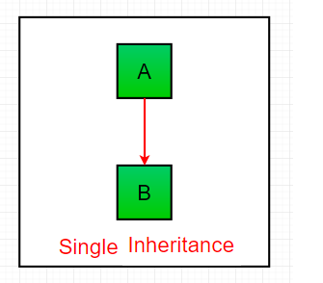
Example:
# Base class
class Parent:
def func1(self):
print("This function is in parent class.")
# Derived class
class Child(Parent):
def func2(self):
print("This function is in child class.")
# Driver code
obj = Child()
obj.func1()
obj.func2()
Output:
This function is in parent class.
This function is in child class.
2. Multiple Inheritance
- When a class can be derived from more than one base class this type of inheritance is called multiple inheritances. In multiple inheritances, all the features of the base classes are inherited into the derived class.
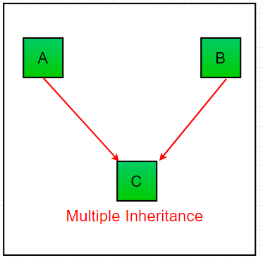
Example:
# Base class 1
class Mother:
mothername = ""
def mother(self):
print(self.mothername)
# Base class 2
class Father:
fathername = ""
def father(self):
print(self.fathername)
# Derived class
class Son(Mother, Father):
def parents(self):
print("Father :", self.fathername)
print("Mother :", self.mothername)
# Driver code
s1 = Son()
s1.fathername = "RAM"
s1.mothername = "SITA"
s1.parents()

Output:
Father : RAM
Mother : SITA
3. Multilevel Inheritance

- In multilevel inheritance, features of the base class and the derived class are further inherited into the new derived class. This is similar to a relationship representing a child and a grandfather.

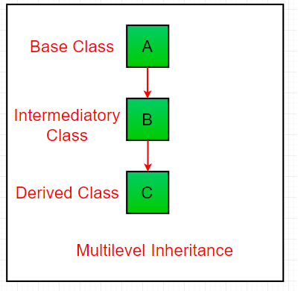
Example:

class Vehicle:
def Vehicle_Info(Self):
print("Vehicle_Information")
class Car(Vehicle):
def Car_Info(self):
print("Car_Information")
class Sports_car(Car):
def Sports_Car(self):
print("Sports_Car Info")
s=Sports_car()
s.Sports_Car()
s.Vehicle_Info()
s.Car_Info()

Output:
Sports_Car Info
Vehicle_Information
Car_Information
4. Hierarchical Inheritance
- When more than one derived class are created from a single base this type of inheritance is called hierarchical inheritance. In this program, we have a parent (base) class and two child (derived) classes.

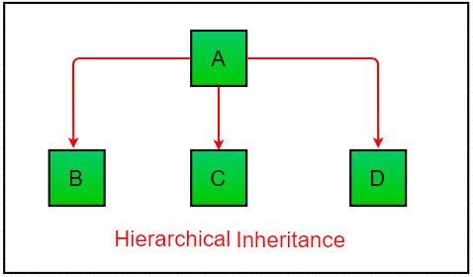
Example:
# Base class
class Parent:
def func1(self):
print("This function is in parent class.")
# Derived class 1
class Child1(Parent):
def func2(self):
print("This function is in child 1.")
# Derived class 2
class Child2(Parent):
def func3(self):
print("This function is in child 2.")
# Driver code
object1 = Child1()
object2 = Child2()
object1.func1()
object1.func2()
object2.func1()
object2.func3()

Output:
This function is in parent class.
This function is in child 1.
This function is in parent class.
This function is in child 2.
5. Hybrid Inheritance
- Hybrid inheritance is a combination of more than one type of inheritance. It uses a mix like single, multiple, or multilevel inheritance within the same program. Python's method resolution order (MRO) handles such cases.
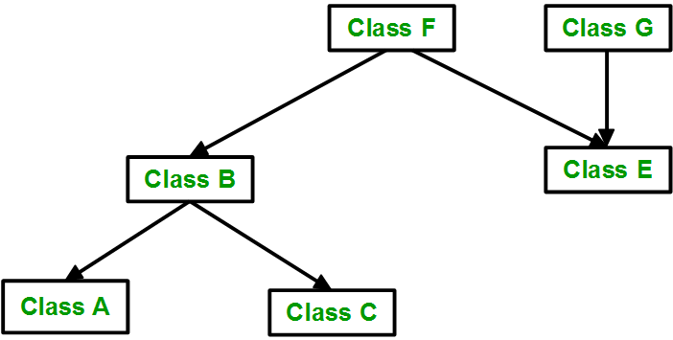

Example:
# Base class
class School:
def func1(self):
print("This function is in school.")
# Derived class 1 (Single Inheritance)
class Student1(School):
def func2(self):
print("This function is in student 1.")
# Derived class 2 (Another Single Inheritance)
class Student2(School):
def func3(self):
print("This function is in student 2.")
# Derived class 3 (Multiple Inheritance)
class Student3(Student1, School):
def func4(self):
print("This function is in student 3.")
# Driver code
obj = Student3()
obj.func1()
obj.func2()

Output:
This function is in school.
This function is in student 1.
Super()

- When a class inherits all properties and behavior from the parent class is called inheritance. In such a case, the inherited class is a subclass and the latter class is the parent class.
- In child class, we can refer to parent class by using the super() function. The super function returns a temporary object of the parent class that allows us to call a parent class method inside a child class method.

Example 1:
class Company:
def Company_Name(self):
print("hello")
return 'Google'
class Employee(Company):
def emp_Info(self):
c_name=self.Company_Name()
print("Jessy works at",c_name)
e=Employee()
e.emp_Info()
Output: hello
Jessy works at Google

Example 2:
class Parent:
def __init__(self, name):
self.name = name
def greet(self):
print(f"Hello from Parent, {self.name}!")
class Child(Parent):
def __init__(self, name, age):
super().__init__(name) # Calls Parent's __init__
self.age = age
def greet(self):
super().greet() # Calls Parent's greet method
print(f"Also, I am {self.age} years old.")
child_instance = Child("Alice", 10)
child_instance.greet()
Output: Hello from Parent, Alice!
Also, I am 10 years old.
issubclass()

- we can verify whether a particular class is a subclass of another class. For this purpose, we can use Python built-in function issubclass(). This function returns True if the given class is the subclass of the specified class. Otherwise, it returns False.

Syntax :
issubclass(class, classinfo)

- class: class to be checked.
- classinfo: a class, type, or a tuple of classes or data types.

Example:

class Company:
def com_info(self):
print("company information")
class Employee(Company):
def empl_info(self):
print("employee information")
class admin(Company):
def admin_info(self):
print("admin information")
print(issubclass(Employee,Company))
print(issubclass(admin,Company))
print(issubclass(Company,admin))
print(issubclass(Company,Employee))

Output:
True
True
False
False

Polymorphism

- Polymorphism means "many forms". It refers to the ability of an entity (like a function or object) to perform different actions based on the context.
- Technically, in Python, polymorphism allows same method, function or operator to behave differently depending on object it is working with. This makes code more flexible and reusable.

Types of Polymorphism
- Polymorphism in Python refers to ability of the same method or operation to behave differently based on object or context. It mainly includes compile-timeand runtime polymorphism.

1. Compile-time Polymorphism(Overloading)

- Compile-time polymorphism means deciding which method or operation to run during compilation, usually through method or operator overloading.

- Languages like Java or C++ support this. But Python doesn’t because it’s dynamically typed it resolves method calls at runtime, not during compilation. So, true method overloading isn’t supported in Python, though similar behavior can be achieved using default or variable arguments.

Example:

- This code demonstrates method overloading in Python using default and variable-length arguments. The multiply() method works with different numbers of inputs, mimicking compile-time polymorphism.

class Calculator:
def multiply(self, a=1, b=1, *args):
result = a * b
for num in args:
result *= num
return result

# Create object
calc = Calculator()

# Using default arguments
print(calc.multiply())
print(calc.multiply(4))

# Using multiple arguments
print(calc.multiply(2, 3))
print(calc.multiply(2, 3, 4))

Output:
1
4
6
24

2. Runtime Polymorphism (Overriding)

- Runtime polymorphism means that the behavior of a method is decided while program is running, based on the object calling it.

- In Python, this happens through Method Overriding a child class provides its own version of a method already defined in the parent class. Since Python is dynamic, it supports this, allowing same method call to behave differently for different object types.

Example:

- This code shows runtime polymorphism using method overriding. The sound() method is defined in base class Animal and overridden in Dog and Cat. At runtime, correct method is called based on object's class.

class Animal:
def sound(self):
return "Some generic sound"

class Dog(Animal):
def sound(self):
return "Bark"

class Cat(Animal):
def sound(self):
return "Meow"

# Polymorphic behavior
animals = [Dog(), Cat(), Animal()]
for animal in animals:
print(animal.sound())

Output:
Bark
Meow
Some generic sound
- Explanation: Here, sound method behaves differently depending on whether object is a Dog, Cat or Animal and this decision happens at runtime. This dynamic nature makes Python particularly powerful for runtime polymorphism.

Abstraction

- Abstraction means hiding unnecessary details and showing only the essential features of an object.

- Real-Life Example: When you drive a car, you use the steering wheel, accelerator, and brake, but you don’t need to know how the engine works internally.

- Similarly in Python, abstraction hides complex logic and shows only what’s needed to the user.

Abstraction in Python using ABC Module

- Python provides abstraction through the abc module (Abstract Base Class).

- Key concepts:

Abstract Class: A class that cannot be instantiated (you can't create objects of it directly).
Abstract Method: A method that has no body (implementation), and must be overridden in the child class.

Example:

from abc import ABC, abstractmethod
# Abstract class
class Animal(ABC):
@abstractmethod
def make_sound(self):
pass # No implementation here
# Child classes must implement the abstract method
class Dog(Animal):
def make_sound(self):
print("Bark")
class Cat(Animal):
def make_sound(self):
print("Meow")
# animal = Animal() # ❌ This will give an error — can't instantiate abstract class
dog = Dog()
cat = Cat()
dog.make_sound()
cat.make_sound()

Output:
Bark
Meow

